Pankhurst Centre Museum & Garden
Tours Information

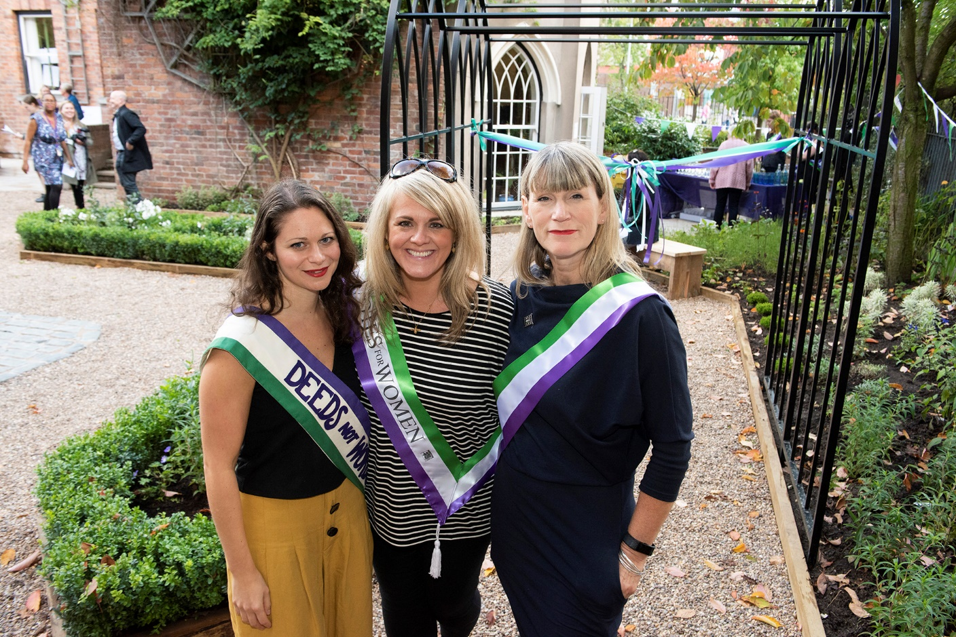

Follow us online: www.pankhursttrust.org #PankhurstCentre
Facebook | Twitter | Instagram
ThePankhurst | @Pankhurst Centre | thepankhurst
Manchester Women's Aid | @MancWomensAid

Address: Pankhurst Centre: 60-62 Nelson Street, Manchester, M13 9WP

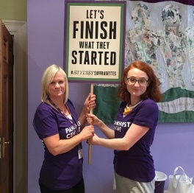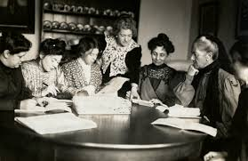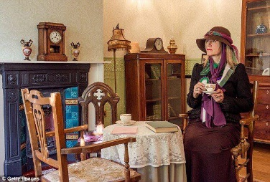

PANKHURST CENTRE TOUR BOOKING ENQUIRY FORM
Lead Contact Name:
Organisation:
Address:
Invoice Address
(If different):
Contact Number:
Email Address: (required)

We usually require 6 weeks advance notice of bookings
Due to the other uses of the Centre tour bookings take place on Tuesday afternoons at 1pm or 3pm

We currently charge a fee of £3.50 per person for a minimum booking of 10 – maximum of 20 per group for a tour lasting approximately 40 minutes to an hour.

Fee payable by cash or cheque payable to The Pankhurst Trust on the day
Or by BACS in advance.

Groups on Centre Open Days
On Thursdays & Sundays when the centre is open bookings can be agreed in advance however if not pre agreed we will do our best to accommodate you and you will be charged £3.50 head for a group of over 10 people.

If you do not book you may be turned away if Centre capacity is exceeded.
If you have any queries please email admin@thepankhurstcentre.org.uk for clarification

Booking Date(s) |  | Booking Time(s)
Number of Visitors |  | Adult/Student?

Do you have any Access Needs?
Is there any additional information required?

This form should be returned by email to: admin@thepankhurstcentre.org.uk
Please note your booking is not confirmed until you receive communication from the Business Team.

Name:
Signature:
Date:

Office Use Only : Agreed Yes ☐ No ☐ Vol assigned Yes ☐ No ☐

About The Pankhurst Trust
Incorporating Manchester Women’s Aid
Learn about the Pankhurst family and the Suffragette movement at the Pankhurst Museum. The museum houses artefacts honouring the Pankhurst family and you are guided by our passionate volunteers.
We also have a beautiful garden, crowdfunded by supporters.

We also have a suffragette shop which stocks a range of Suffragette & Feminist themed gifts and books with all proceeds supporting the work of the Centre.

Manchester Women’s Aid runs a weekly Women’s Social Drop-In, provides 1-1 Outreach support, Counselling Services, Group Counselling, Refuge support and works closely with Emmeline’s Pantry Food Bank.
See the website https://pankhursttrust.org/ for more information

Museum Opening Times
Every Thursday between 10am and 4pm
2nd & 4th Sunday of the month between 1pm and 4pm
Visit the website for this month’s dates and special events and opening

Support Us
https://pankhursttrust.org/get-involved/fundraising
As a registered charity we are constantly fundraising.
Join the Friends from £3 per month or an annual fee of £25 or contact the team for a fundraising pack.

Getting to the Pankhurst Centre
We are located on Nelson Street off Oxford Road on the grounds of Manchester Royal Infirmary

By Car We have no on-site visitor parking except for those with access needs.
There is a NCP car park on Grafton Street, a short walk away.
Up to 3 hours – £2.50, 3-6 hours £5 and 6-24 hours £15.

By Train The nearest train stations Oxford Road Station and Piccadilly Train Station are a short walk or bus journey to the Pankhurst Centre.

By Bus Several bus routes to the Manchester Royal Infirmary run along Oxford Road from the City Centre and from Albert Square.
These include the following services: 15, 18, 41, 42, 43, 50, 53, 111, 142,143,147,197, V1, V2

By Bike
We have no facilities for cycle parking however there are several bike racks outside Morrisons and on Oxford Road.

Local Attractions
We are a short walk from Elizabeth Gaskell’s House, Chuck Gallery, The Whitworth and Manchester Museum.

Member of the HiDDEN8 - Eight hidden gems in and around Manchester city centre. Historic buildings with rare collections, displays, exhibitions and events. thehidden8.com

Visit the homes of two of Manchester’s most famous women

Elizabeth Gaskell’s House
& The Pankhurst Centre

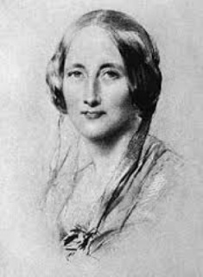
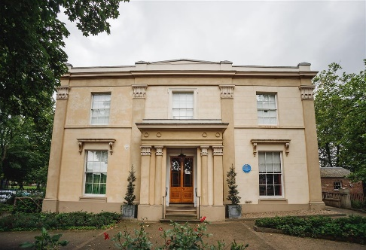
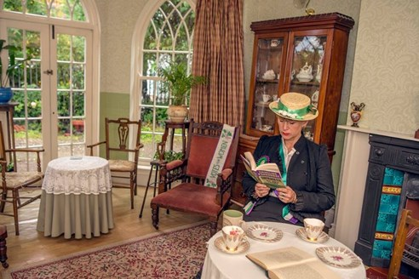

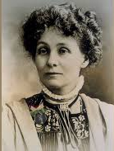

Enjoy a bespoke tour of the beautifully restored historic home of the Victorian author Elizabeth Gaskell and the birth place of the suffragette movement and former home of Emmeline Pankhurst, on a history filled day trip to Manchester.

- Available to pre-book on Tuesdays
- From £17 per person
- Private tours of both venues given by expert guides
- Tea/coffee and cake at Elizabeth Gaskell’s House
- Lunch available at an additional cost
- Minimum of 15 people / maximum 40 people
- One booking and point of contact
- Could be combined with a visit to the nearby Whitworth Art Gallery.

Call 0161 273 2215 or email
enquiries@elizabethgaskellhouse.co.uk

